DAY-6 PROGRAMS

1. To implement the median of medians algorithm ensure that you handle the worst case time complexity efficiency while finding the k-th smallest element in an unsorted array.

Arr=[12,3,5,7,19] k=2

Expected output:5

Code:

import random

def median_of_medians(arr, k):

if len(arr) == 1:

return arr[0]

subarrays = [arr[i:i+5] for i in range(0, len(arr), 5)]

medians = [sorted(subarray)[len(subarray)//2] for subarray in subarrays]

if len(medians) <= 5:

pivot = sorted(medians)[len(medians)//2]

else:

pivot = median_of_medians(medians, len(medians)//2)

left = [x for x in arr if x < pivot]

middle = [x for x in arr if x == pivot]

right = [x for x in arr if x > pivot]

if k <= len(left):

return median_of_medians(left, k)

elif k <= len(left) + len(middle):

return middle[0]

else:

return median_of_medians(right, k - len(left) - len(middle))

arr = [12, 3, 5, 7, 19]

k = 2

print(median_of_medians(arr, k))

output:

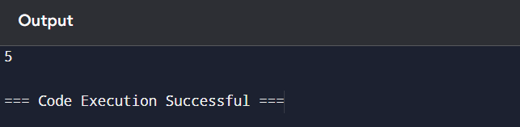

2. To implement a function median of medians (arr,k)that takes an unsorted array arr and an integer,and return the k-th smallest element in the array.

Arr=[1,2,3,4,5,6,7,8,9,10] k=6

Output:An intrger representing the k-th smallest elements in the array.

Code:

import random

def median_of_medians(arr, k):

if len(arr) == 1:

return arr[0]

subarrays = [arr[i:i+5] for i in range(0, len(arr), 5)]

medians = [sorted(subarray)[len(subarray)//2] for subarray in subarrays]

if len(medians) <= 5:

pivot = sorted(medians)[len(medians)//2]

else:

pivot = median_of_medians(medians, len(medians)//2)

left = [x for x in arr if x < pivot]

middle = [x for x in arr if x == pivot]

right = [x for x in arr if x > pivot]

if k <= len(left):

return median_of_medians(left, k)

elif k <= len(left) + len(middle):

return middle[0]

else:

return median_of_medians(right, k - len(left) - len(middle))

arr = [1, 2, 3, 4, 5, 6, 7, 8, 9, 10]

k = 6

print(median_of_medians(arr, k))

output:

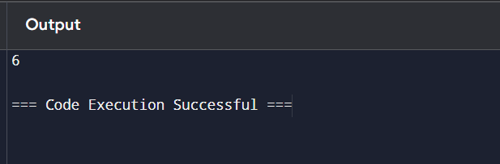

3. write a program to implement meet in the middle technique.give an array of integers and a target sum , find the subset whose sum is closest to the target. You will use the meet in the middle technique

To eifficiency find this subset.

Set=[45,34,4,12,5,2]

Target sum=42

Code:

from itertools import combinations

def meet_in_the_middle(arr, target):

n = len(arr)

mid = n // 2

left_half = arr[:mid]

right_half = arr[mid:]

def get_subset_sums(arr):

subset_sums = set()

for r in range(len(arr) + 1):

for combo in combinations(arr, r):

subset_sums.add(sum(combo))

return sorted(subset_sums)

left_sums = get_subset_sums(left_half)

right_sums = get_subset_sums(right_half)

closest_sum = None

closest_diff = float('inf')

for left_sum in left_sums:

target_right_sum = target - left_sum

low, high = 0, len(right_sums) - 1

while low <= high:

mid = (low + high) // 2

right_sum = right_sums[mid]

current_sum = left_sum + right_sum

current_diff = abs(current_sum - target)

if current_diff < closest_diff:

closest_diff = current_diff

closest_sum = current_sum

if current_sum < target:

low = mid + 1

else:

high = mid - 1

return closest_sum

arr = [45, 34, 4, 12, 5, 2]

target = 42

closest_sum = meet_in_the_middle(arr, target)

print(f"The subset sum closest to {target} is {closest_sum}.")

output:

